Assignment – Graphs

Comp310 Object oriented data structures in Java

# TopicS

Graph representations, implementations and traversals.

# Readings

Carrano: Chapters 28 & 29

# Objectives

Represent a problem as a graph and apply graph traversal algorithms to solve the problem.

# Instructions

## Represent a maze as a graph

* 1. **Intersections, entrance and exits** are the vertices of the graph and the corridors between them are the edges.
  2. Read in a maze configuration from a file (*so you can test your program/algorithms with different configurations)* and store in an adjacency list representation of a graph that you write yourself.
  3. Display the initial maze *(how you display is up to you).* Indicate, in some manner, the entrance and the exits.

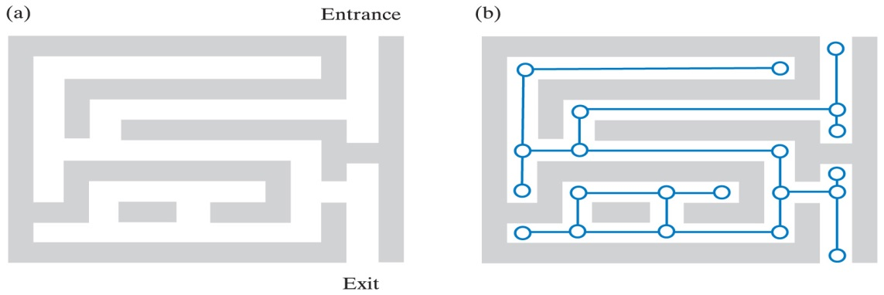

Figure – Example from the text a) Maze b) Representation as a graph

## Searching for solutions

* 1. Implement the **Depth First Search (DFS)** traversal algorithm to find a solution through your maze
     1. **Show the progression that the algorithm makes though the maze**

**including reaching dead ends and back tracking**

* + 1. **Indicate, at the end, the final solution**

***Direct path that was found from entrance to exit not including backtracking vertices***

* 1. Implement the **Breadth First Search** traversal algorithm to find shortest path through your maze
     1. **Indicate, at the end, the final solution**

***Direct path that was found from entrance to exit not including backtracking vertices***

Blank moved up

Blank moved left

# Analysis / Summary

Answer the following either in paragraph form or as answers to the numbered items:

## Analysis

* 1. Which algorithm (BFS or DFS) do you think is the **best** for **this type** of problem, in general? Explain.
  2. Which algorithm is more **realistic** in terms of someone who would actually traverse a maze *(i.e., a corn maze in the fall)?*

## Summary

* 1. If you worked in pairs:
     1. **How did you “divide up” the work so that each student still met the objectives for the assignment (i.e., learned, understood and applied the concepts).**
     2. **What was your contribution?**
     3. **How did you coordinate code changes/testing?**
     4. **Other observations about working with a partner?**
  2. Where did you have trouble with this assignment? How did you move forward? What topics still confuse you?
  3. What did you learn from this assignment? *(Please be specific)*